Nginx
Tasks

TASK 1
Nginx Fundamentals & Reverse Proxy
Overview
Set up and configured Nginx by installing and running it, serving static content, configuring a reverse proxy, handling errors, and securing access. The setup was implemented on a single EC2 instance with Nginx and a Node.js backend application on the same server.

Server Details:
Instance ID: i-0343ddb105325e52f
Public IP Adress: 98.93.241.164
OS Used: Linux

1 | Install Nginx

sudo dnf install nginx -y
sudo systemctl enable nginx
sudo systemctl start nginx
sudo systemctl status nginx

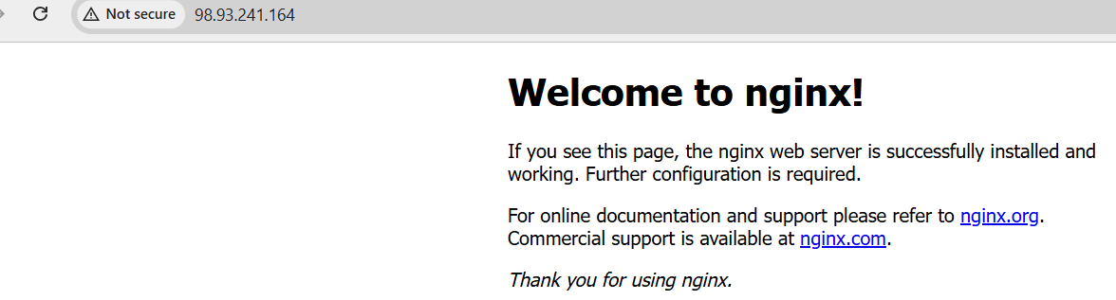
2 | Serve Static Content

sudo mkdir -p /var/www/mysite
sudo bash -c 'echo "<h1>Welcome to My Static Site</h1>" > /var/www/mysite/index.html'
sudo chmod -R 755 /var/www/mysite
sudo chown -R nginx:nginx /var/www/mysite

mysite.conf server block using root and index directives:
server {
listen 80;
server_name 98.93.241.164;
root /var/www/mysite;
index index.html;
location / {
try_files $uri $uri/ =404;
}
}

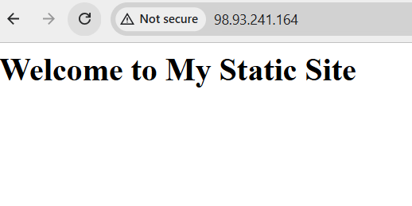
3 | Run Backend App on Port 3000

nohup node ~/backend.js > ~/backend.log 2>&1 &
curl http://localhost:3000
# Returns: Hello from backend on port 3000


4 | Configure Reverse Proxy

location /api/ {
proxy_pass http://127.0.0.1:3000/;
proxy_set_header Host $host;
proxy_set_header X-Real-IP $remote_addr;
proxy_set_header X-Forwarded-For $proxy_add_x_forwarded_for;
proxy_set_header X-Request-URI $request_uri;
}
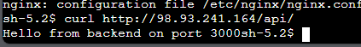
5 | Custom Error Pages

error_page 404 /404.html;
error_page 403 /403.html;
location = /404.html { internal; }
location = /403.html { internal; }



6 | Modular nginx.conf with include Directive

The http block in nginx.conf loads all site configs automatically via include:
http {
include /etc/nginx/mime.types;
include /etc/nginx/conf.d/*.conf;
include /etc/nginx/snippets/*.conf;
}

7 | Security Headers

# /etc/nginx/snippets/security-headers.conf
add_header X-Frame-Options "SAMEORIGIN" always;
add_header X-XSS-Protection "1; mode=block" always;
add_header X-Content-Type-Options "nosniff" always;
add_header Referrer-Policy "no-referrer" always;

8 | Nginx Variables

location / {
add_header X-Host $host;
add_header X-Client-IP $remote_addr;
add_header X-Request-URI $request_uri;
try_files $uri $uri/ =404;
}

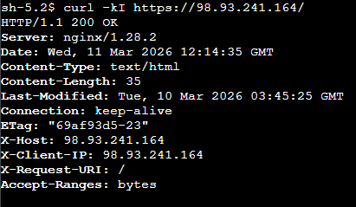
9 | Basic Authentication

sudo dnf install httpd-tools -y
sudo htpasswd -c /etc/nginx/auth/.htpasswd admin
location /admin {
auth_basic "Restricted Area";
auth_basic_user_file /etc/nginx/auth/.htpasswd;
try_files $uri $uri/ =404;
}

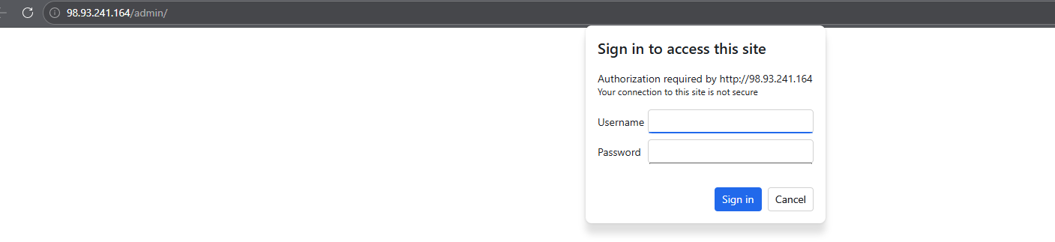

TASK 2
Advanced Nginx Features

Overview
Task 2 builds on Task 1 by adding advanced Nginx capabilities. Three Node.js backends simulate a real multi-server environment. SSL/TLS encrypts all traffic. Caching, rate limiting, and buffering improve performance and reliability.

1 | Three Backend Servers on Ports 8080, 8081, 8082

nohup node ~/backend/server_8080.js > ~/backend/8080.log 2>&1 &
nohup node ~/backend/server_8081.js > ~/backend/8081.log 2>&1 &
nohup node ~/backend/server_8082.js > ~/backend/8082.log 2>&1 &
Response from all three ports:
2 | Load Balancing — Round Robin, Least Connections, IP Hash

# /etc/nginx/conf.d/upstream.conf
upstream backend_rr {
server 127.0.0.1:8080;
server 127.0.0.1:8081;
server 127.0.0.1:8082;
}
upstream backend_lc {
least_conn;
server 127.0.0.1:8080;
server 127.0.0.1:8081;
server 127.0.0.1:8082;
}
upstream backend_ip {
ip_hash;
server 127.0.0.1:8080;
server 127.0.0.1:8081;
server 127.0.0.1:8082;
}

3 | SSL/TLS with Self-Signed Certificate + HTTP to HTTPS Redirect

sudo openssl req -x509 -nodes -days 365 -newkey rsa:2048 \
-keyout /etc/nginx/ssl/nginx-selfsigned.key \
-out /etc/nginx/ssl/nginx-selfsigned.crt \
-subj "/C=US/ST=State/L=City/O=Lab/CN=98.93.241.164"
sudo openssl dhparam -out /etc/nginx/ssl/dhparam.pem 2048

# HTTP block — redirects to HTTPS
server {
listen 80;
server_name 98.93.241.164;
return 301 https://$host$request_uri;
}
# HTTPS block
server {
listen 443 ssl;
ssl_certificate /etc/nginx/ssl/nginx-selfsigned.crt;
ssl_certificate_key /etc/nginx/ssl/nginx-selfsigned.key;
ssl_dhparam /etc/nginx/ssl/dhparam.pem;
ssl_protocols TLSv1.2 TLSv1.3;
}

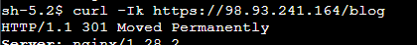

4 | URL Rewriting and Redirects

# Internal rewrite — browser URL unchanged
location /old-page {
rewrite ^/old-page$ /new-page.html last;
}
# Permanent redirect
location /blog {
return 301 /articles.html;
}
# Regex redirect
location ~ ^/products/(.*)$ {
return 301 /items/$1;
}

5 | Proxy Caching with TTL Validation

# nginx.conf http block
proxy_cache_path /var/cache/nginx levels=1:2 keys_zone=my_cache:10m
max_size=1g inactive=60m use_temp_path=off;
# /api/ location block
proxy_cache my_cache;
proxy_cache_valid 200 302 10m;
proxy_cache_lock on;
add_header X-Cache-Status $upstream_cache_status always;

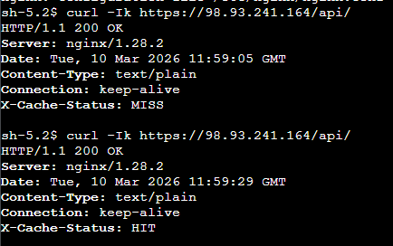

6 | Rate Limiting and Connection Limits

# nginx.conf http block
limit_req_zone $binary_remote_addr zone=req_limit:10m rate=10r/s;
limit_conn_zone $binary_remote_addr zone=conn_limit:10m;
# location / block
limit_req zone=req_limit burst=20 nodelay;
limit_conn conn_limit 10;

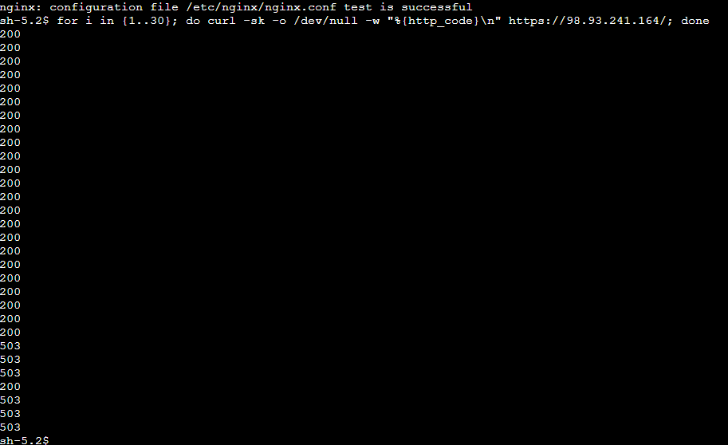

7 | Buffering Settings

# /etc/nginx/conf.d/buffering.conf
proxy_buffering on;
proxy_buffer_size 4k;
proxy_buffers 8 16k;
proxy_busy_buffers_size 32k;
client_body_buffer_size 16k;
client_max_body_size 20m;

TASK 3
Multi-Site Hosting & Monitoring

Overview
Task 3 demonstrates hosting two completely independent websites on a single Nginx server using virtual hosting. Each site has its own server block, its own web root, and its own log files. A custom detailed log format is used across both sites for enhanced monitoring and troubleshooting.

1 | Create 2 Site Directories and Content

sudo mkdir -p /var/www/site1/html
sudo mkdir -p /var/www/site2/html
sudo bash -c 'echo "<h1>Site One</h1>" > /var/www/site1/html/index.html'
sudo bash -c 'echo "<h1>Site Two</h1>" > /var/www/site2/html/index.html'
sudo chown -R nginx:nginx /var/www/site1 /var/www/site2

2 | Separate Server Blocks for Each Site

# /etc/nginx/conf.d/site1.conf
server {
listen 80;
server_name site1.example.local;
root /var/www/site1/html;
index index.html;
access_log /var/log/nginx/site1-access.log detailed;
error_log /var/log/nginx/site1-error.log warn;
location / { try_files $uri $uri/ =404; }
}
# /etc/nginx/conf.d/site2.conf
server {
listen 80;
server_name site2.example.local;
root /var/www/site2/html;
index index.html;
access_log /var/log/nginx/site2-access.log detailed;
error_log /var/log/nginx/site2-error.log warn;
location / { try_files $uri $uri/ =404; }
}

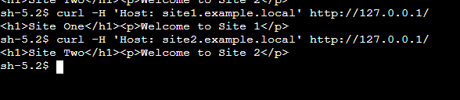

3 | Custom Detailed Log Format

# Added to nginx.conf http block
log_format detailed '$time_iso8601 $remote_addr "$request" '
'status=$status bytes=$body_bytes_sent '
'host=$host uri=$request_uri '
'cache=$upstream_cache_status '
'rt=$request_time urt=$upstream_response_time';

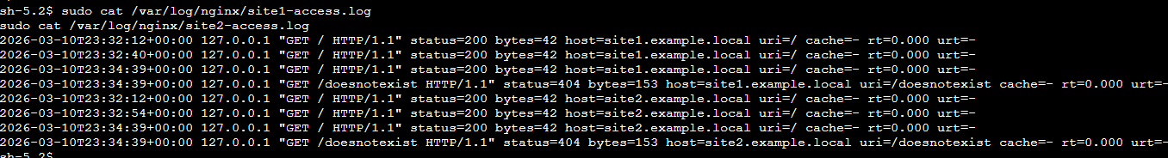

4 | Live Monitoring and Log Analysis

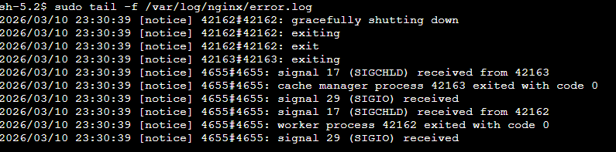

5 | Deliberately Trigger and Diagnose an Error

Triggered 404 errors on site1 by requesting non-existent pages, then diagnosed them using log commands:
curl -H 'Host: site1.example.local' http://127.0.0.1/missing-page
curl -H 'Host: site1.example.local' http://127.0.0.1/another-missing
# Find and diagnose the errors
sudo grep 'status=404' /var/log/nginx/site1-access.log

